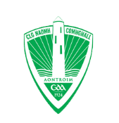
APPENDIX 3
INCIDENT/ACCIDENT REPORTING FORM – St Comgall’s Antrim

This form should be used for each occasion of
• Accidental fall/injury
• Aggressive behaviour
• Verbal abuse
• Destruction of equipment or property (or threats of)
• Physical assault (or threats of)

PLEASE SEND COMPLETED FORMS TO: childrensofficer.stcomgalls.antrim@gaa.ie

Name of person completing this form:
Role/Position of person completing this form:
Signature of person completing this form:
Date:

INCIDENT/ACCIDENT

Date and time of incident:

Name/s of person/s involved in the incident and their Clubs/Associations:
What activity was taking place when the incident occurred?
Description of incident:
What action, if any, did Club personnel take during or after the incident?

Witnesses (include contact details
NAME | CONTACT

REPORTING OF THE INCIDENT TO CLUB/ASSOCIATION

Incident Reported to:
Date:
How was the incident/accident reported? e.g. using this form, in person, email, phone

FOLLOW UP ACTION
Description of actions to be taken:

CLUB/ASSOCIATION NOTES ONLY:

